**VEHICLE PROBLEM**

**Michael Christopher 2440047362**

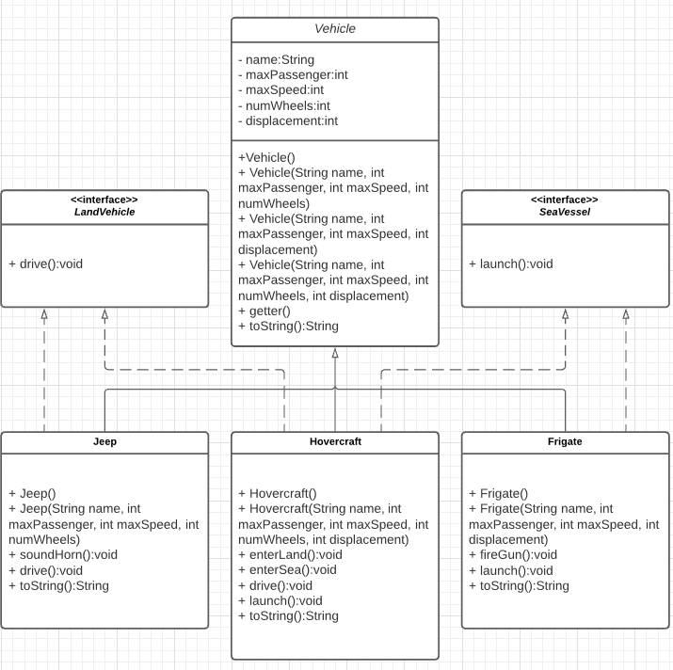

2A.

package exercise;  
  
public interface IsEmergency {  
  
 public void soundSiren();  
}

2B.

public class PoliceCar extends Vehicle implements IsEmergency, LandVehicle

2C.

private boolean onDuty;

public boolean isOnDuty() {  
 return onDuty;  
}

2D.

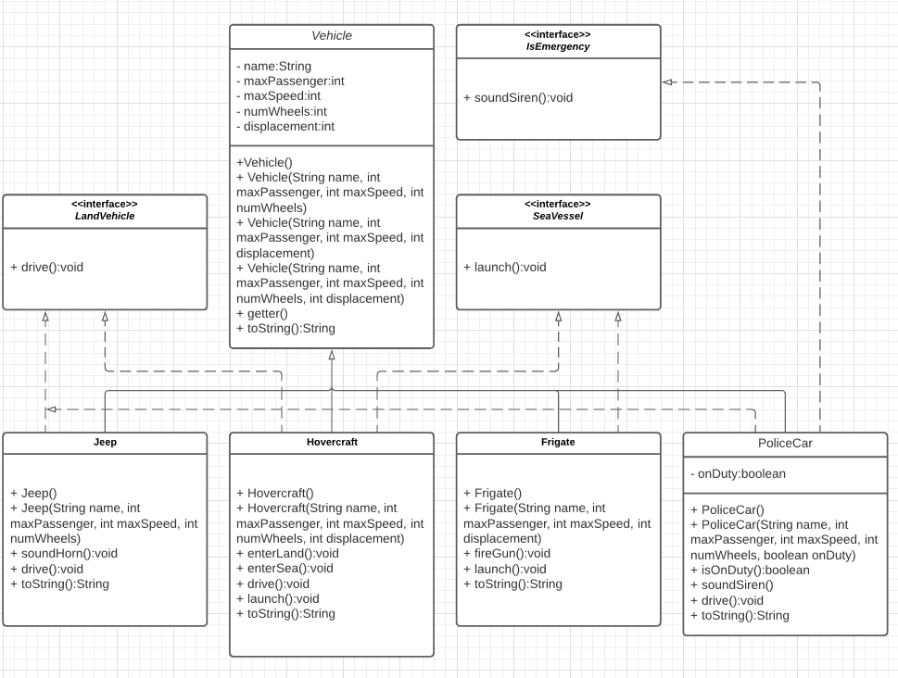

2E.

PoliceCar policeCar = new PoliceCar("NYPD", 5, 245, 4, true);  
PoliceCar policeCar1 = new PoliceCar("CPD", 4, 210, 4, false);  
PoliceCar policeCar2 = new PoliceCar("POLIZIA", 6, 234, 4, true);  
  
ArrayList<PoliceCar> policeCars = new ArrayList<>();  
policeCars.add(policeCar);  
policeCars.add(policeCar1);  
policeCars.add(policeCar2);

Full code is on the github